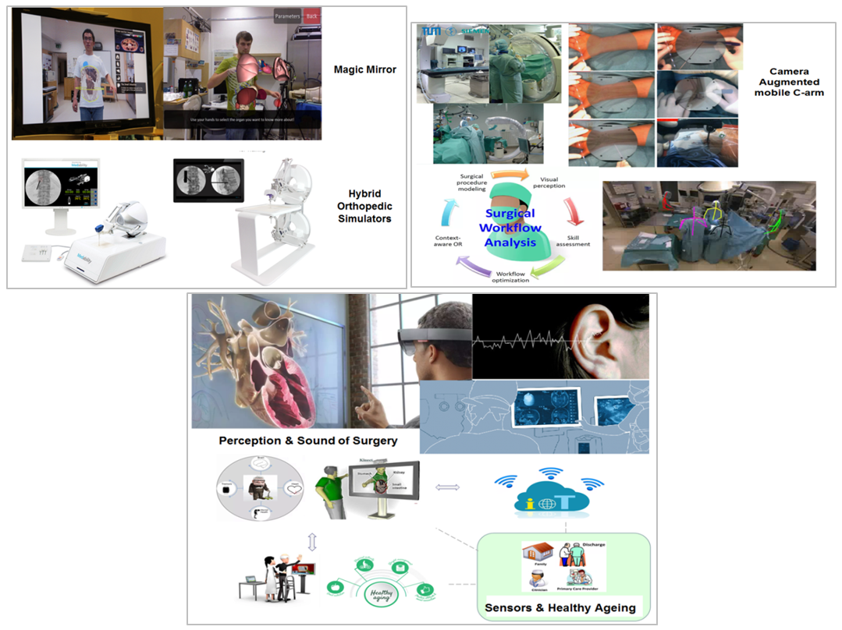

MEDICAL EDUCATION, TRAINING, AND COMPUTER ASSISTED INTERVENTIONS

(METRICS Lab)

The lab explores the impact of novel technologies and how these should be integrated to ensure the development and sustainment throughout the duration of professional careers in medicine with particular focus on surgery, while ensuring positive patient outcomes and fostering healthy habits for healthy aging.

Looking for motivated students with one or more of the following:
C++, Networking, OpenCV, OpenGL, Robotics, Sensors, Mobile Apps, Computer Vision.

Contact
Prof. Pascal Fallavollita
Interdisciplinary School of Health Sciences
School of Electrical Engineering & Computer Science
Tel: 613-562-5800 ext.3986
Email: pfallavo@uottawa.ca

